**SELF STABILIZING PLATFORM**

**Introduction**

There exist mechanical devices for which it is important to retain a constant position, or a constant direction regardless of their space fitting. Classical applications of such systems include a camera stabilisation in moving systems, a platform stabilisation for mobile guidance systems, or other special cases. This project is one such solution to this problem of stabilisation.

The project defines an easy implementation of self stabilization platform with standard part available. The self stabilization platform has various bigger applications as well, which include auto pilot mode in aeroplane, anti motion sickness chairs etc.

**Why did we decide to make this project?**

The objectives and goals of this project include demonstration of techniques involved in balancing platform, working on precise movements and accurate control of platform, identifying the correct connections needed for peripheral hardware to communicate with microcontroller and to establish the power supply to each of electrical components.

**Materials and Methods**

**Components Used:**

* Hardware

|  |  |  |  |
| --- | --- | --- | --- |
| Sr. No. | Name of component | Picture | Description |
|  | Arduino UNO |  | Arduino UNO is a microcontroller board based on the ATmega328. It has 20 input/output pins, a 16 Mhz resonator, a USB connection, a power jack, an in-circuit system programming header, and a reset button. |
| 2. | Gyroscope MPU-6050 board GY-521 |  | It is a MEMS sensor with an accelerometer and gyro sensor in a single chip. It is very accurate and has an internal 16 bit ADC for each channel. And the sensors interface easily to Arduino using 12C protocol. |
| 3. | Servo moter |  | Servomotor is used here as it is very easy to operate and has an internal feedback mechanism so no external feedback is required for the platform. |
| 4. | Breadboard |  | A breadboard is a solderless device for temporary prototype with electronics and test circuit designs. Most electronic circuits can be interconnected by inserting their leads or terminals into the holes and then making connections through wires where appropriate. |
| 5. | Battery Holder |  |  |

Mechanical Materials:

* Two rectangular sheets
* Adhesive (apoxy resins)
* Fevicol
* U shaped aluminium sheets
* Screw and nuts

Software

1. Arduino IDE

Arduino IDE contains a text editor for writing code, a message area, a text console, a toolbar with buttons for common functions and a series of menus. It connects to the Arduino and Genuino hardware to upload programs and communicate with them.

2. Fritzing

Fritzing is an open source hardware initiative that makes electronics accessible as a creative material for anyone. It is a software tool and a community website for processing and Arduino, fostering a creative ecosystem that allows users to document their prototypes, share them with others, teach electronics in a classroom and manufacture professional PCB’s.

Methods

Step 1:Circuit Design

Following connections are being made:

* Battery holder positive to Vin Arduino
* 5V Arduino pin to Breadboard Power supply
* GY521 INT Pin to Arduino Pin 2
* GY521 SDA Pin to Arduino A4 Pin
* GY521 SCL Pin to Arduino A5 Pin
* Ground (GY521) to Ground (Breadboard)
* VCC Sensor (GY521) to VCC (Breadboard)
* Ground (Servometer) to Ground (Breadboard)
* VCC Ground to Ground (Breadboard)
* Pulse Pin (Servo) to Arduino pin 5

Step 2:Procedure

* The Gyroscope sensor is a 6 axis sensor which works on spherical coordinates.The position from which it started is considered as the origin position.
* The Arduino is programmed in accordance with Gyroscope. When a threshold value is reached, that is, any value greater than origin, the microcontroller Arduino activates the servometer so as to manipulate the platform in a stabilized position of the origin.
* The Servometer is programmed in such a way it rotates in opposite direction to that of direction of motion which in turn keeps the platform in a stable position, which prevents the falling of object.

**Schematics**

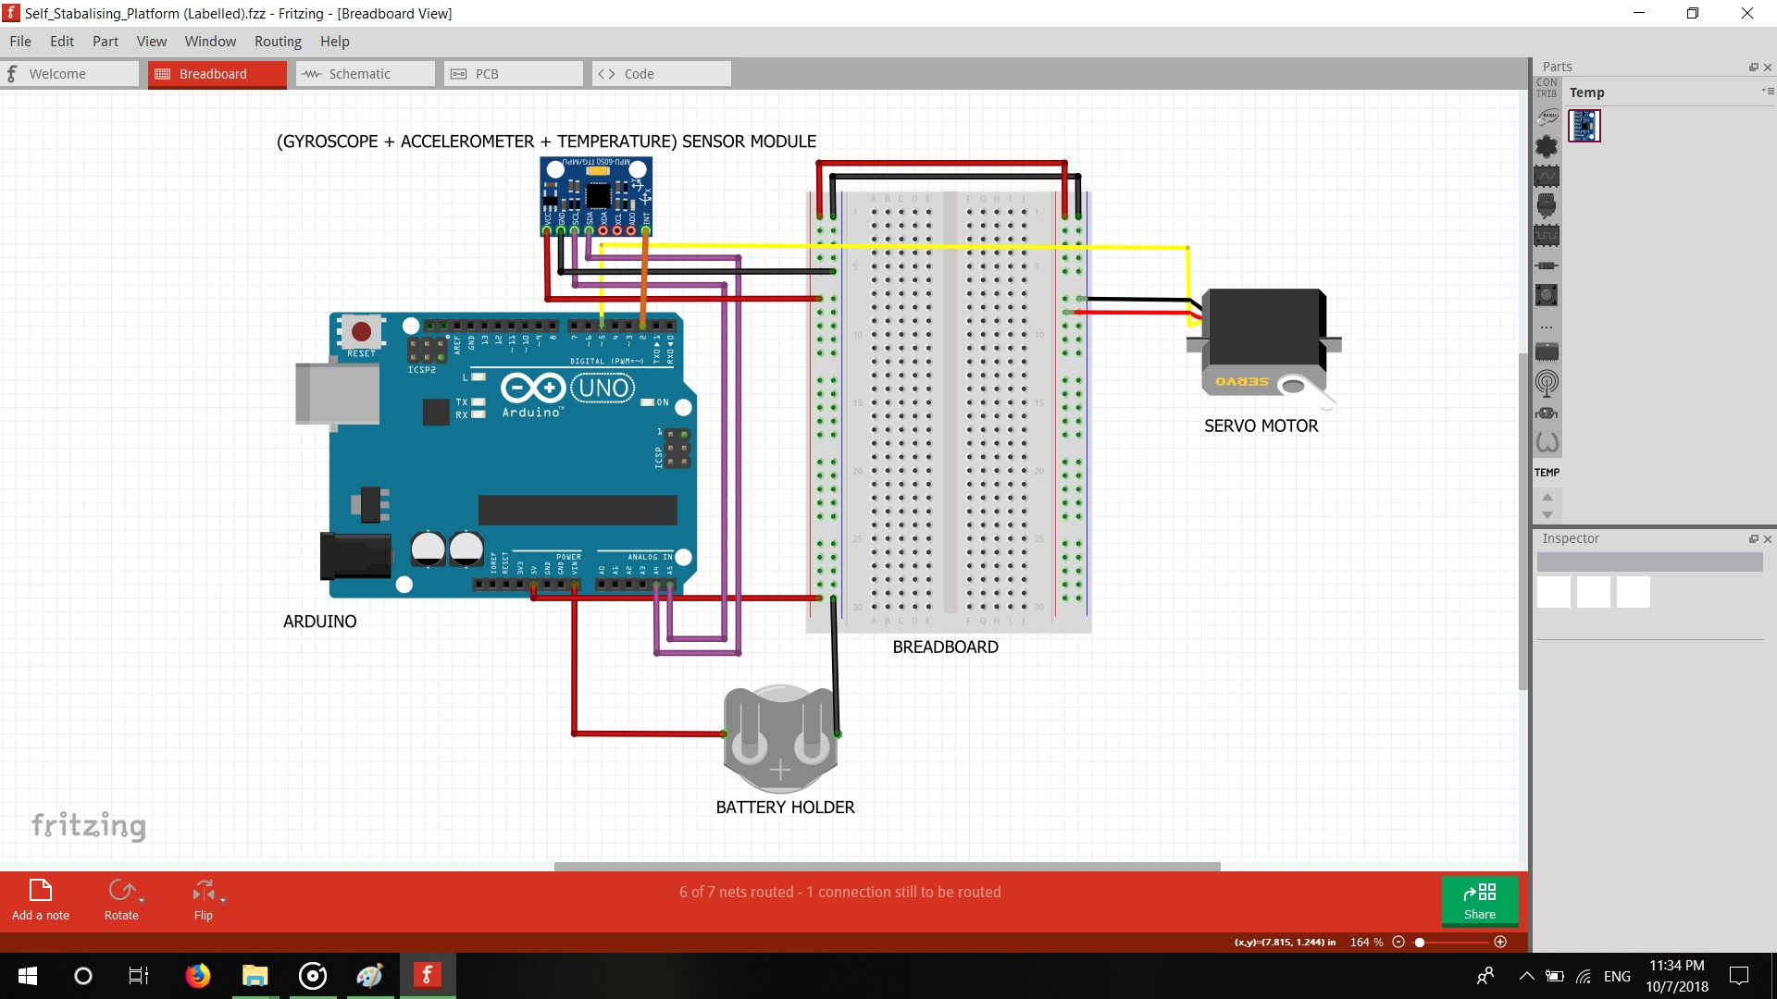

**Cad Model**

**Future Scope**

1. Auto stable cameras can be constructed using self stabilization systems.
2. In future, self stabilizing bikes can be made which can help to prevent accidents.
3. Flight control can be stabilised using this type of systems.
4. The speed and the robustness of the system can also be improved using better methods.